Dices
1. | Choose the box that is similar to the box formed from the given sheet of paper (X).  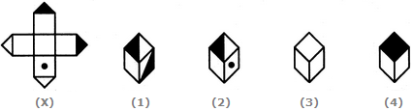
1 and 2 only
2 and 4 only
2 and 3 only
1 and 4 only

2. | Choose the box that is similar to the box formed from the given sheet of paper (X).  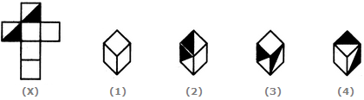
1 and 4 only
3 and 4 only
1 and 2 only
2 and 3 only

3. |  | How many dots lie opposite to the face having three dots, when the given figure is folded to form a cube?  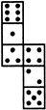
2
4
5
6

4. |  |  |  | Choose the box that is similar to the box formed from the given sheet of paper (X).  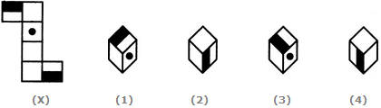
1 and 2 only
2 and 3 only
2 and 4 only
1, 2, 3 and 4

5. |  |  |  | Choose the box that is similar to the box formed from the given sheet of paper (X).  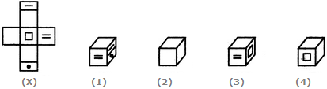
1 only
1 and 3 only
1, 3 and 4 only
1, 2, 3 and 4

6. |  |  |  |  | Choose the box that is similar to the box formed from the given sheet of paper (X).  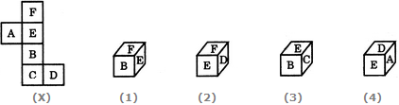
1 only
2 only
1 and 3 only
1, 2, 3 and 4 only

7. |  |  |  |  |  | Choose the box that is similar to the box formed from the given sheet of paper (X).  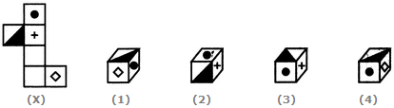
1 only
2 only
3 only
4 only

8. |  |  |  |  |  |  |  | Choose the box that is similar to the box formed from the given sheet of paper (X).  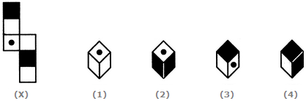
2 and 3 only
1, 3 and 4 only
2 and 4 only
1 and 4 only

9. |  |  |  |  |  |  |  | Observe the dots on a dice (one to six dots) in the following figures. How many dots are contained on the face opposite to that containing four dots?  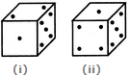
2
3
6
Cannot be determined

10. |  |  |  |  |  |  |  |  | Three different positions of a dice are shown below. How many dots lie opposite 2 dots?  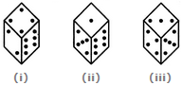
1
3
5
6

11. |  |  |  |  |  |  |  |  |  | The six faces of a dice have been marked with alphabets A, B, C, D, E and F respectively. This dice is rolled down three times. The three positions are shown as:  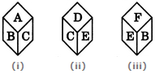  Find the alphabet opposite A.
C
D
E
F

12. |  |  |  |  |  |  |  |  |  | Three positions of a dice are given. Based on them find out which number is found opposite the number 2 in the given cube.  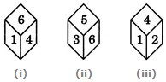
6
5
3
1

13. |  |  |  |  |  |  |  |  |  | A dice is thrown four times and its four different positions are shown below. Find the number on the face opposite the face showing 2.  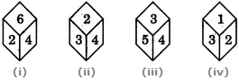
3
4
5
6

14. |  |  |  |  |  |  |  |  |  | A dice is rolled twice and the two positions are shown in the figure below. What is the number of dots at the bottom face when the dice is in position (i)?  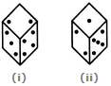
1
5
6
Cannot be determined

15. |  |  |  |  |  |  |  |  |  | Below are depicted the three different positions of a dice. Find the number of dots on the face opposite to the face with one dot.  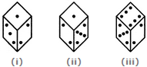
2
3
4
6

16. |  |  |  |  |  |  |  |  |  | Two positions of a parallelepiped are shown below. When the number 3 will be on the top side, then which number will be at the bottom?  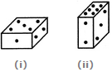
1
4
5
6

